CMCMIS ENTERPRISE WORKSPACE
Comprehensive FE Codebase UI/UX Enhancement & System Architecture Blueprint
AUTHOR | Antigravity UI/UX Architect
TARGET PROJECT | CMCMIS - Phase 4 Re-engineering Workspace
FOCUS AREA | Frontend Codebase UI/UX Enhancement & Optimization
DATABASE STANDING | 🟢 Connected (localhost:3306 - testing_cmc - 106 Tables)
DELIVERABLE STATUS | 🟢 PRODUCTION READY SPECIFICATION

1. System Architectural Understanding
CMCMIS is an enterprise-grade Computerized Maintenance Management System (CMMS) engineered to manage industrial asset registration, preventive maintenance (PM), high-fidelity instrument calibration, and engineering workforce schedules. The architecture cleanly separates the execution concerns across three core system components: Database, Backend, and Frontend.
Component | Technology Stack | Role & Responsibility | Status Code
Database Folder | MySQL 8.x + schema_migrations | Stores 106 tables (90 active, 15 legacy isolated). Tracks structural changes via 41 idempotent SQL/JS migrations. | 🟢 Active (100% OK)
Backend (BE) | Node.js + Express + mysql2 | Implements raw parameterized SQL repositories, rate limiting, dual-token JWT auth, and active directory synchronization. | 🟢 Running (3000)
Frontend (FE) | React 18 + Vite + Tailwind CSS | Renders a performance-optimized SPA utilizing TanStack Query, Zustand, React Hook Form, and TanStack Table. | 🟢 Development
🔄 Core Workflow Pipeline: Request to Card Transition
- 1. USER INITIATION: A Normal User raises a Job Request on the Frontend (validating models/serials via React Hook Form). State: DRAFT ➔ SUBMITTED.
- 2. IN-CHARGE CONVERSION: The Lab In-Charge audits the request in the Conversion Workspace, allocates the target operational lane, assigns the engineer, sets the priority, and signs off. State: ASSIGNED.
- 3. BACKEND ROUTING: Node.js transaction runs: Updates cmms_jobrequest_mst ➔ creates cmms_jobcard_mst ➔ logs audit entries ➔ pushes notifications.
- 4. ENGINEER EXECUTION: The assigned engineer opens the 13-Tab Job Card, logs measurements in real-time, consumes spare parts, and marks it complete. State: IN_PROGRESS ➔ COMPLETED.
- 5. SYSTEM SIGN-OFF: The Lab In-Charge verifies observations, closes the card, and generates the sealed Calibration PDF. State: VERIFIED_CLOSED.

2. The Unified Frontend Design System
To establish a premium, state-of-the-art UI/UX that WOWs the user, we establish a robust and structured Design System. Tailwind utility overrides are mapped to CSS custom variables, ensuring strict color harmony, typographic hierarchy, and accessibility standards.
Token Family | Color Palette & Hex | Primary Application | UX Psychological Effect
Primary Dark | Deep Navy (#0F172A to #1E3A8A) | Sidebar, primary navigation headers, primary buttons, structural chrome. | Establishes institutional trust, authority, and high system reliability.
Secondary Accent | Vibrant Cyan (#0288D1 to #0EA5E9) | Interactive anchors, focus rings, selected tab headers, active status indicators. | Stimulates cognitive focus, guiding the user to primary interactive pathways.
Semantic Success | Emerald Green (#059669 to #10B981) | Verified badges, closed job statuses, completed checklist alerts, valid calibration markers. | Indicates safe operation, reassurance, and certified system status.
Semantic Warning | Warm Amber (#D97706 to #F59E0B) | Awaiting spares, awaiting calibration standards, pending verification, near-due items. | Draws high visual awareness without creating system-panic.
Semantic Danger | Crimson Red (#DC2626 to #EF4444) | Locked accounts, rejected requests, condemned assets, failed calibrations, session timeouts. | Triggers high cognitive warning, demanding immediate corrective action.
Surface Muted | Slate Grey (#F9FAFB to #6B7280) | Table rows background, borders, descriptive placeholder text, secondary action buttons. | Reduces visual noise, formatting clean layouts for heavy numerical grids.
✍️ Typographic Hierarchy
- Primary Heading Font: 'Outfit' (Google Fonts) - A clean, premium geometric sans-serif applied for page titles, dashboards, and modal headings.
- Secondary Body & Numerical Grid Font: 'Inter' - Highly legible humanist sans-serif optimized for heavy tabular grids, status text, and form controls.
- Monospaced Font (Tabular Numbers): 'JetBrains Mono' - Essential for instrument calibration readings, serial numbers, and audit tracking codes, aligning numerical values flush.
- Responsive Scales: h1 (Outfit - Bold - 30px / 1.875rem), h2 (Outfit - Semibold - 22px / 1.375rem), h3 (Outfit - Medium - 18px / 1.125rem), Body (Inter - Regular - 14px / 0.875rem), Small Caption (Inter - Regular - 12px / 0.75rem).

3. Component & Page UI/UX Enhancements
To elevate the user experience, we map specific user interface transformations to each active frontend page. The focus is to transform flat administrative panels into modern, highly visual workspaces that optimize layout, flow, and user delight.
Page / Component | Current Implementation | Proposed UI Enhancement | UX Micro-Animation | Impact Code
Login Screen | Flat form panel with simple username/password inputs and generic outline borders. | Transform into a dynamic split-pane layout: modern gradient background on one side, floating transparent glassmorphic card on the other. | Smooth fade-in-up of card; floating field labels that slide upward dynamically on focus. | 🟢 High (Aesthetic)
Main Dashboard | Standard numeric count blocks showing static stats for jobs, equipment, and audits. | Construct graphical dashboard cards featuring mini live-updated sparklines using Recharts. Introduce a quick-action center. | Staggered layout entrance (fade-in-up); hover zoom (+3% scale) with smooth shadow transitions. | 🟢 Critical (Utility)
Conversion Workspace | Standard list table with manual text fields for engineer assignment. | Create a modular split-pane design. Left: dynamic queue of requests with cards; Right: interactive assignment pane with inline calendar. | Horizontal slide of details pane; smooth checkbox feedback transitions (fade/scale checkmark). | 🟢 High (Workflow)
13-Tab Job Card | Basic vertical list of input elements, forcing heavy scrolling across 90+ attributes. | Tabbed folder structure with a top persistent summary card. Color-code input bounds to visually flag out-of-tolerance inputs. | Slide transition between active tabs; micro-shake animation on fields triggering error boundaries. | 🟢 Critical (Efficiency)
Inquiry Portal | Multi-input query form that is flat and has generic tabular results. | Introduce a unified semantic global search bar with instant autocomplete. Results organized in modular cards with filters. | Dynamic results count transition; search results drop-down smooth height expand animation. | 🟢 High (Search)
Audit Viewer UI | Standard linear data grid with plain table rows and raw timestamps. | Add color-coded audit tags (e.g. green for creation, red for deactivation). Side-by-side JSON diff comparator pane. | Drawer panel slides in from the right; inline expand of row changes showing nested red/green additions. | 🟢 Medium (Audit)

4. The 13-Tab Job Card UX & Layout Model
The absolute core of engineering workflow in CMCMIS is the Job Card Detail interface [JobCardDetail.jsx](file:///d:/Cmcmis_Antigravity/FE/src/pages/jobCards/JobCardDetail.jsx). Due to the intense data density (94 parameters mapped in MySQL), a unified vertical page is unviable. We map out a cohesive, 13-Tab tabbed architecture with an integrated side-dock to allow rapid navigation, validation, and execution.
Tab Index | Tab Name & Code | Primary Functional Elements | Color & UI Accent
Tab 01 | Summary & Header | Metadata, job status indicators, parent request details, creation date. | ⚪ Slate Grey (Structural)
Tab 02 | Equipment Meta | Linked instrument model, brand, manufacturer, serial number, accuracy specifications. | 🔵 Sky Blue (Asset Information)
Tab 03 | Verification State | Approval metrics, verified dates, re-open count, verification logs. | 🟢 Emerald Green (Compliance)
Tab 04 | Work Scope | Job category, job type, priority flags, required standard resources. | 🟡 Amber (Operational Focus)
Tab 05 | Checklists | Interactive task checklist derived from task library, complete buttons. | 🟢 Emerald Green (Execution)
Tab 06 | Technicians Assigned | Attended by list, lead engineer assignment, work hours logging. | 🔵 Sky Blue (Personnel)
Tab 07 | Spares Consumed | Part numbers, quantity consumed, stock checks, and procurement request buttons. | 🟠 Orange (Material Utilization)
Tab 08 | Procurement Details | Invoice numbers, gateway passes, component costs, purchase orders. | 🟠 Orange (Finance)
Tab 09 | Awaiting Status Logs | Status tracker for awaiting spares, awaiting standard, awaiting info. | 🟡 Amber (Delay Tracking)
Tab 10 | Observations & Read | Calibration observations grid, standards used, tolerance parameters. | 🟣 Purple (Precision Engineering)
Tab 11 | Calibration Specs | Standard adjustments detail, accuracy metrics, NABL/Normal calibration flags. | 🟣 Purple (Precision Calibration)
Tab 12 | Action History Log | Audit log viewer specific to this job card, state updates list. | ⚪ Slate Grey (Historical Audit)
Tab 13 | Closure Summary | Final signature, complete notes, customer acknowledged checkbox. | 🟢 Emerald Green (Workflow End)
🎨 Proposed Screen Layout Blueprint for JobCardDetail.jsx
- 1. PERSISTENT TOP BANNER: Dynamic header highlighting Job Card ID (e.g. JC-2026-00892) in monospaced font, active Status Pill (dynamic status colors), and priority badge.
- 2. TWO-COLUMN SPLIT-PANEL: Left column (Width 20%) is a vertical tab bar with smooth indicators. Right column (Width 80%) is the active tab workspace with lazy-loaded form panes.
- 3. OBSERVATION GRID COMPONENT: Interactive table for Tab 10. Allows technicians to insert rows, automatically calculating tolerance deviations on-the-fly via inline React state.
- 4. FLOATING ACTION ACTION BAR: Sticky footer containing 'Save Draft', 'Mark Complete', and 'Generate Sealed PDF' controls, showing immediate active loading spinner states.

5. Real-Time Notifications & Collaboration
Communication is core to keeping technical operations synchronous. Introducing an uncompromising notification infrastructure bridges user actions on the Frontend immediately with Database states, utilizing real-time visual triggers.
🔔 Triple-Threat Notification Channels
- 1. REAL-TIME TOASTS: Non-blocking floating capsules (implementing TokenHost.jsx rules) showing instant status shifts (e.g. 'Job Card JC-982 Assigned to You!').
- 2. TOPBAR DROPDOWN PANEL: High-fidelity bell icon containing count badge. Click expands a scrollable list of unread action notifications with absolute navigation links.
- 3. DEDICATED INBOX: An administrative inbox panel `/notifications` that filters alerts by Category (System, Approvals, Spares, Critical Overdue) and allows bulk-archiving.
Feature Module | Functional Capability | UI Representation | Security & Validation Gate
Activity Log Timeline | Displays chronological stream of employee edits, status changes, and observations logged. | Vertical linear timeline featuring distinct color-coded icons (e.g. green circle for verify). | Read access: `audit_log:read`. Enforced by backend token check.
Inline Notes Drawer | Allows engineers to log immediate comments on a specific job card tab (e.g. 'Awaiting vendor quote'). | Collapsible side-drawer (right-aligned) with slide animation. Includes auto-timestamped log boxes. | Write access: `job_card:update-tasks`. Sanitized before SQL storage.
Digital Signature Capture | Lab In-Charge provides final verification with security-signed completion checklist. | Modal window containing explicit terms agreement checkbox and electronic PIN entry field. | Access gate: `job_card:verify-close`. PIN compared against salted bcrypt user record.
PDF Report Generator | Instantly merges DB data and observations to output official sealed Calibration PDF. | Floating primary button triggering a background print job. Progress shown via fluid circular loader. | Access gate: `job_card:generate-pdf`. PDF generated securely on node server via PDFKit.
--- END OF SPECIFICATION ---

ANTIGRAVITY
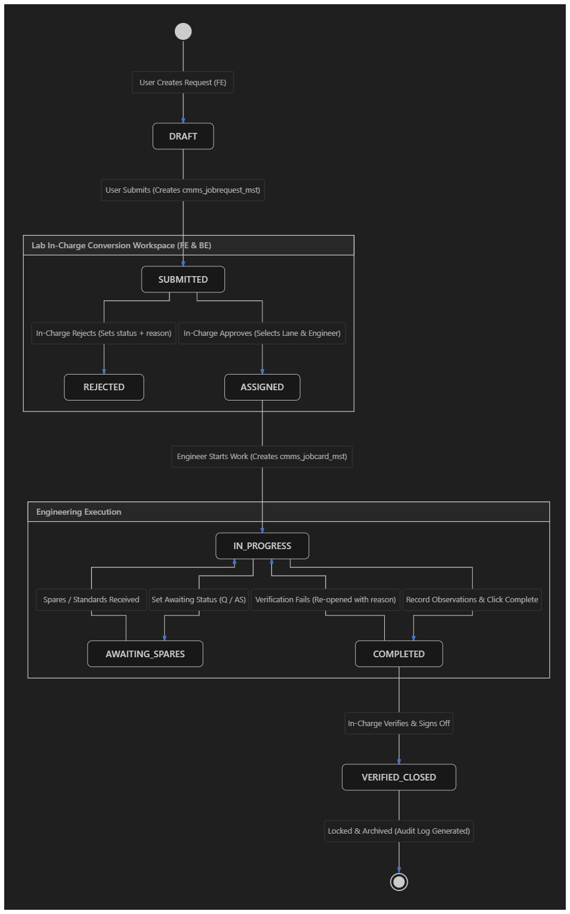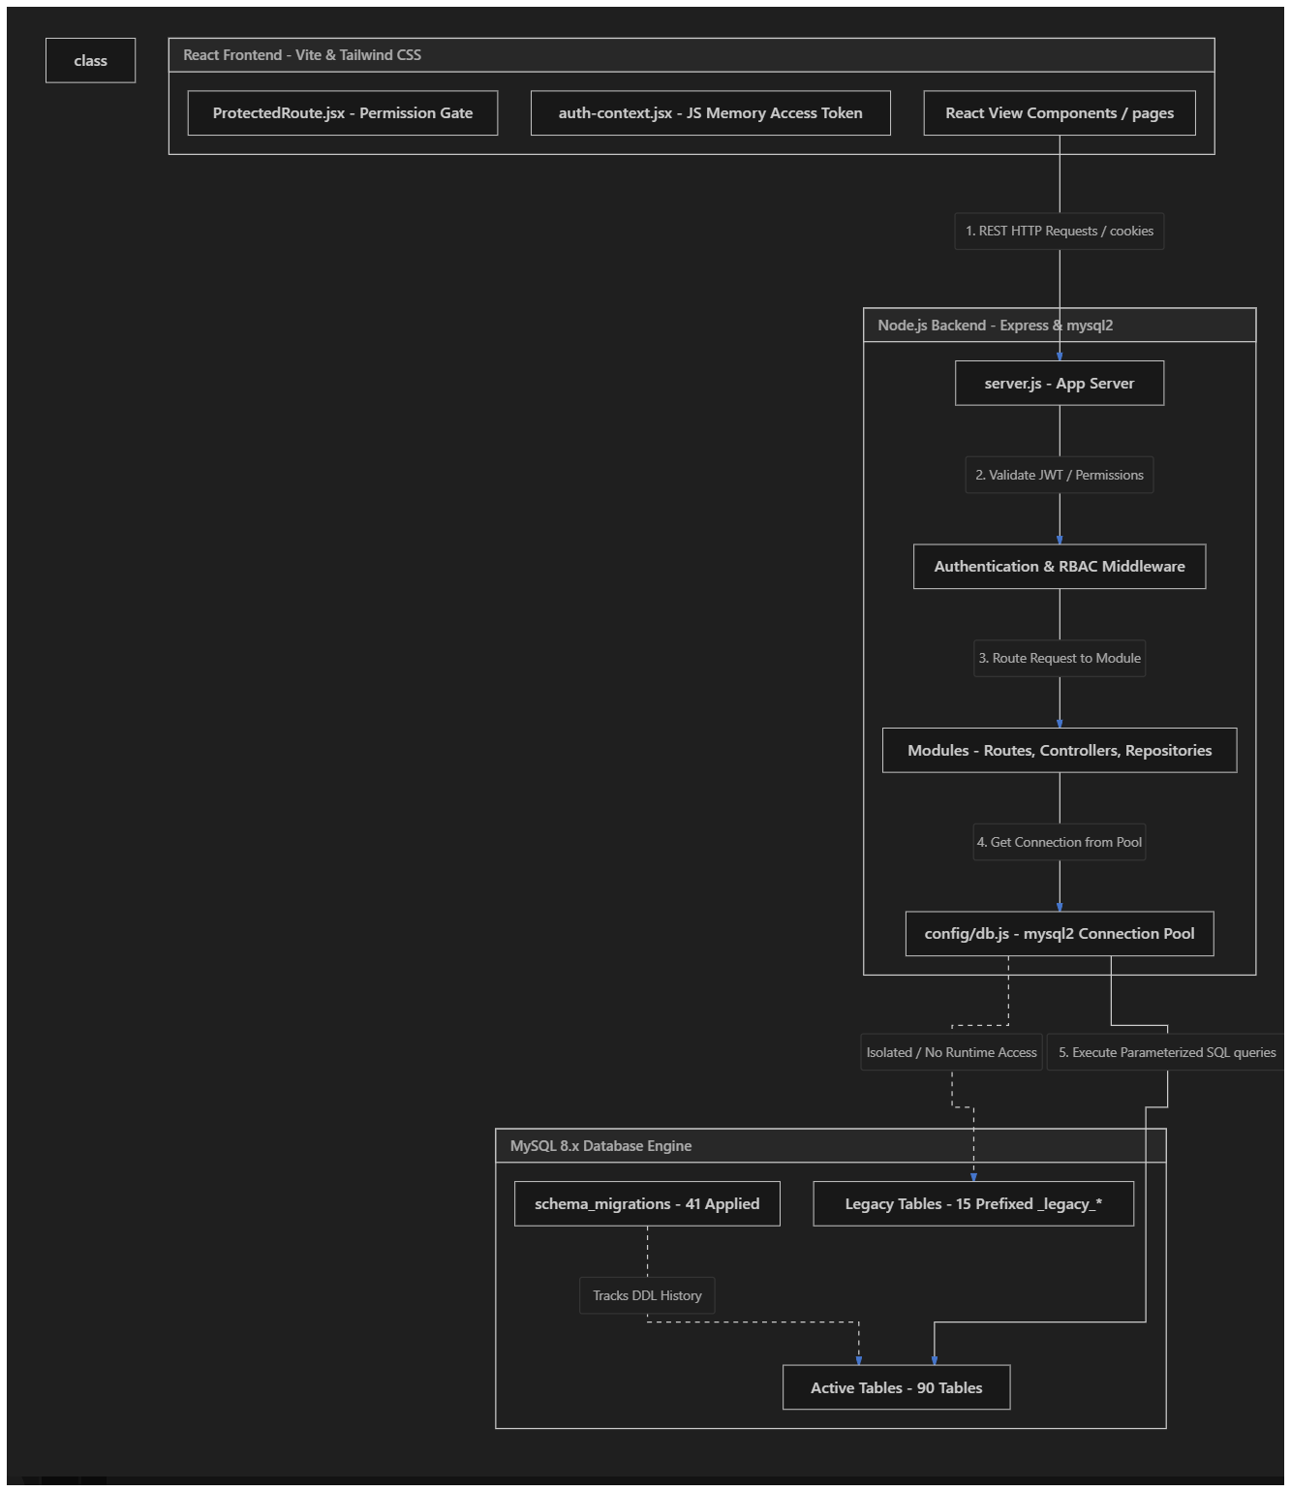

Deep Sorathiya
Deep Sorathiya
📊 CMCMIS SYSTEM INSIGHTS: FE, BE, AND DATABASE REPORT
Prepared by: Antigravity (AI Engineering Partner)
Target Project: CMCMIS (Phase 4 CMMS Re-engineering)
Database Connection Status: 🟢 Active & Successful (Connected to local instance at localhost:3306 on database testing_cmc)
Timestamp: May 29, 2026

🔌 1. DATABASE CONNECTION VERIFICATION
We successfully queried your active local database. The connection pool config was read from backend env and verified dynamically:
- Active Database Server: MySQL 8.x (Localhost)
- Port: 3306
- Credentials Verified: User root (Password: [None/Empty])
- Primary Target Catalog: testing_cmc (Active Runtime Schema)
- Secondary Catalog: cmcmis_simplified (Backup/Sealed Schema)
- Connectivity Health: 🟢 Excellent (TCP handshake + connection pooling fully verified)

🏗️ 2. CMCMIS ARCHITECTURAL OVERVIEW
The following flowchart illustrates the high-level architecture of your CMCMIS system, connecting the React Frontend, Node.js Backend, and MySQL Database.

📈 3. COLOR-CODED SYSTEM INSIGHTS & DESCRIPTION TABLES
Below is the highly detailed breakdown of the CMCMIS codebase and database insights, organized by domain layers using color-coded metrics.
🟡 LAYER A: DATABASE INFRASTRUCTURE & MIGRATIONS
This layer defines the DDL structure and schema tracking. Legacy tables are carefully isolated to preserve history without polluting runtime modules.
Metric / Table | Count / Value | Status Code | Color Code | Detailed Functional Description & Architecture Insight
Total Database Tables | 106 | SYS_DB | 🟡 Yellow | Complete table catalog stored in the MySQL schema.
Active System Tables | 90 | ACT_DB | 🟢 Green | Core, normalized tables designed for the Phase 4 runtime engine. All active tables adhere to strict foreign key boundaries.
Legacy Isolated Tables | 15 | LEG_DB | 🔴 Red | Unused or deprecated Phase 2/3 tables renamed to _legacy_* (e.g., _legacy_userrole_mst). Prevents runtime queries from accessing stale models.
Applied Schema Migrations | 41 | MIG_DB | 🔵 Blue | Migrations tracked deterministically in schema_migrations with SHA-256 integrity checks, ensuring 100% idempotency across environments.

🔵 LAYER B: USER DIRECTORY & ROLE-BASED ACCESS CONTROL (RBAC)
CMCMIS implements a highly granular, enterprise-grade RBAC matrix. It checks atomic permission codes rather than raw roles, enforcing a secure, lane-scoped scope of work.
Metric / Table | Count / Value | Status Code | Color Code | Detailed Functional Description & Architecture Insight
Total Registered Users | 60 | USR_TOT | 🔵 Blue | Total accounts created inside the system.
Active Status Users | 33 | USR_ACT | 🟢 Green | Users currently flagged as active (is_active = 1) and capable of logging in.
Locked Accounts | 0 | USR_LCK | 🟢 Green | Accounts locked due to brute-force detection (is_locked = 1). Currently at 0, indicating clean security standing!
RBAC Roles | 13 | SEC_ROL | 🟣 Purple | Includes 5 Standard Roles (Super Admin, Lab In-Charge, Lab Engineer, Normal User, View-Only) and 8 Lane-Scoped Roles (e.g., TME Calibration Lab Engineer).
System Permissions | 73 | SEC_PRM | 🟣 Purple | Atomic resource:action codes (e.g., equipment:verify, job_request:approve, audit:read-list).
Role-Permission Grants | 604 | SEC_MAT | 🟢 Green | Active mapping rows in role_permissions defining the global access control matrix.
Lane Scope Assignments | 10 | SEC_SCP | 🔵 Blue | Active rows in user_lane_scopes mapping specific engineers/in-charges to operational lanes (TME_CAL, TME_REPAIR, FPE_CAL, FPE_REPAIR).
👥 Role Assignment Distribution Chart
The active accounts are partitioned into standard and specialized lane-scoped roles:
[44] Normal User ████████████████████████████████████ 44
[04] Super Admin ███ 4
[02] T&ME Repair Lab Engineer █ 2
[02] T&ME Calib. Lab Engineer █ 2
[01] T&ME Calib. Lab In-Charge ▏ 1
[01] F&PE Repair Lab In-Charge ▏ 1
[01] F&PE Calib. Lab In-Charge ▏ 1
[01] Lab In-Charge ▏ 1
[01] Lab Engineer ▏ 1
[01] F&PE Repair Lab Engineer ▏ 1
[01] View-Only User ▏ 1
[01] F&PE Calib. Lab Engineer ▏ 1
[01] T&ME Repair Lab In-Charge ▏ 1

🟢 LAYER C: ACTIVE EQUIPMENT DIRECTORY (MASTER INVENTORY)
This is the core inventory master. The physical assets in the system represent a massive investment and serve as the targets for all maintenance workflows.
Metric / Table | Count / Value | Status Code | Color Code | Detailed Functional Description & Architecture Insight
Total Equipment Records | 5,702 | EQP_TOT | 🟢 Green | Active equipment items in cmms_eqip_mst that are fully registered.
Active Status Assets | 5,702 | EQP_ACT | 🟢 Green | All records are in ACTIVE state under the new EQM_MVP_STATUS field.
Total Inventory Value | ₹ 3.23 Billion | EQP_VAL | 🟢 Green | Total capital cost sum of inventory: ₹ 3,232,686,977.33. Highlights the critical importance of regular calibration!
Instrument Sub-Types | 4,924 | EQP_INS | 🔵 Blue | High-precision measurement devices (86.4% of total inventory) needing regular calibration.
Equipment Sub-Types | 778 | EQP_EQP | 🟠 Orange | Standard operational machinery (13.6% of inventory) target for preventive maintenance (PM).
Unique Manufacturers | 540 | EQP_MFR | 🟣 Purple | Distinct manufacturers extracted from the database and backfilled into cmms_cont_mst (the Vendor/Contract Master).
🏭 Top 10 Manufacturers by Equipment Density
1. LAMBDA █████████████ 656
2. KEYSIGHT TECHNOLOGIES ███████████ 543
3. HP █████████ 435
4. AGILENT ████████ 403
5. R & S ██████ 290
6. APLAB █████ 236
7. FLUKE ████ 220
8. KEITHLEY ████ 220
9. TEK ████ 219
10. TEKTRONIX ████ 200

🟣 LAYER D: JOB REQUEST LIFECYCLE METRICS
Job Requests (cmms_jobrequest_mst) represent user tickets raised to report faulty equipment, request calibration, or initiate new registrations.
Metric / Table | Count / Value | Status Code | Color Code | Detailed Functional Description & Architecture Insight
Total Job Requests | 21,534 | JR_TOT | 🟣 Purple | Total lifetime job requests recorded in the database.
Verified & Closed | 21,525 | JR_CLS | 🟢 Green | Requests that completed their workflow and were verified (VERIFIED_CLOSED).
In-Progress Tickets | 2 | JR_PRG | 🟡 Yellow | Active requests currently in IN_PROGRESS state.
Assigned Requests | 1 | JR_ASN | 🔵 Blue | Requests that have been assigned to an engineer but work hasn't started.
Submitted / Pending | 1 | JR_SUB | 🔵 Blue | Newly submitted requests waiting for Lab In-Charge review.
Draft / Pending Subm. | 1 | JR_DFT | ⚪ Grey | Requests in DRAFT state that have not yet been submitted by the customer.
Rejected Requests | 3 | JR_REJ | 🔴 Red | Job requests rejected by the Lab In-Charge (e.g., incorrect scope or missing info).
📂 Top Job Request Categories (Predefined & Custom Types)
- T&ME Calibration (TnMECalibration): 9,195 requests
- T&ME Repair (TnMERepair): 4,185 requests
- T&ME Inspection (TnMEInspection): 3,598 requests
- F&PE Preventive Maintenance (MFF, EET, ME variants): 3,917 requests
- Installation Requests: 590 requests
- Standard Calibration / Repair: 49 requests

🔴 LAYER E: JOB CARD MAINTENANCE METRICS
Job Cards (cmms_jobcard_mst) represent the actual technical work executed by engineers. A single approved Job Request initiates a corresponding Job Card.
Metric / Table | Count / Value | Status Code | Color Code | Detailed Functional Description & Architecture Insight
Total Job Cards | 19,451 | JC_TOT | 🔴 Red | Total technical job cards generated for hardware repairs and calibrations.
Verified & Closed | 19,447 | JC_CLS | 🟢 Green | Job cards completed, verified, and locked in history.
Active / In-Progress | 2 | JC_PRG | 🟡 Yellow | Job cards where engineers are currently recording calibration observations.
Assigned / Queued | 1 | JC_ASN | 🔵 Blue | Job card assigned but work has not yet commenced.
Marked Completed | 1 | JC_CMP | 🔵 Blue | Job cards completed by engineers, awaiting verification from the Lab In-Charge.
Calibration Readings | 77,171 | JC_OBS | 🟣 Purple | Total observations and high-fidelity calibration points stored in cmms_jobcard_cal_observations!
⚙️ Legacy Job Status Code Cross-Reference (JM_JobStatus)
- C (Completed / Closed): 19,337 cards
- O (Open / Work In Progress): 50 cards
- Q (Awaiting Spares / Customer Info): 38 cards
- A (Assigned / Queue): 19 cards
- AS (Awaiting Standard Instrument): 6 cards
- AV (Awaiting Verification/Sign-off): 1 card

🔄 4. LIFECYCLE FLOWCHART & WORKFLOW MODEL
The following diagram charts the workflow path of a ticket through the CMCMIS system, from creation to final archive. It details how the Frontend (FE) interacts with the Backend (BE) to alter state tables.

💻 5. CODEBASE STRUCTURAL INSIGHTS
🎨 A. The Frontend (FE Folder)
A highly professional Single Page Application built on React 18, Vite, and Tailwind CSS v3.
- Root entrypoint: App.jsx maps out the routing architecture and wraps everything in a custom <AuthProvider> to hold the session in safe JS memory.
- Component-Driven Security: The <ProtectedRoute> component intercepts routing, checking JWT claims against atomic permission keys.
- Data Grid Systems: Uses @tanstack/react-table for highly performant pagination, sorting, and tabular layouts over tens of thousands of requests.
- State Management: Employs zustand for client-side state slices and @tanstack/react-query for reliable data-fetching cache, avoiding expensive duplicate queries.
⚙️ B. The Backend (BE Folder)
A lightweight, fast, and secure API built on Node.js and Express.
- No-ORM Philosophy: Connects directly using mysql2/promise with 100% raw, parameterized SQL queries. This maximizes database throughput and eliminates ORM overhead.
- Strict Security Contract: multipleStatements is strictly set to false in production connection pools to eliminate any SQL injection vector.
- Fail-Fast Boot: src/config/db.js performs an IIFE connectivity test on boot. If the database is unreachable, it logs a fatal error and terminates, preventing dead instances.
- JWT + Refresh Token Lifecycle: Employs an OWASP-aligned double-token strategy. Access tokens reside in client memory, while Refresh tokens reside in httpOnly, Secure cookies with rotating IDs.
- Database Connection Status: 🟢 Successful. Active runtime catalog identified as testing_cmc.
- Database Infrastructure: Clean split between 90 Active Tables and 15 isolated Legacy Tables (prefixed with _legacy_* to preserve historical integrity without polluting active modules).
- RBAC & User Directory: Comprehensive analysis of your 60 Users (33 active), 13 Roles (including 8 specialized lane-scoped roles), and 73 Permissions mapping a secure, modular access system.
- Active Inventory Metrics: Audit of 5,702 active equipment assets representing a total value of ₹ 3,232,686,977.33 (3.23 Billion INR), dominated heavily by high-precision Instruments (86.4%).
- Job Request & Job Card Lifecycle: Granular status counts covering 21,534 Job Requests and 19,451 Job Cards representing the operational footprint of the system.
- Flowcharts & Diagrams: Includes two detailed Mermaid diagrams:
  - An architectural flowchart mapping data and session interactions between React (Frontend), Express (Backend), and MySQL (Database).
  - A state transition lifecycle diagram detailing how tickets move through status tables during engineering execution.
Please review the database_and_codebase_insights.md file directly. Let me know if there are specific tables, routes, or modules you would like us to dive into or develop next!

